ECE 465 Lab 9
Synchronous Sequential Circuit Construction
Summary
In the previous lab, you learned what a finite state machine is, and how they’re utilized in theory. In this lab, you’re going to experiment with Synchronous Sequential Circuits, which are state machines, and understand how they correlate with SSC’s.

- Consider the following figure.
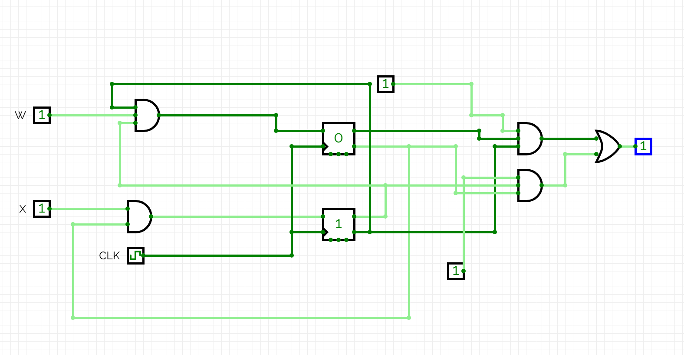
Is this a mealy or moore machine? Explain your answer.

- An input sequence X ending in ‘101’ will produce an output Z = 1. $X=0011011001010100$, Z = $0000010000010100$.
- Construct the state diagram and transition table
- Build SSM using BCD, while also drawing the encoding state
- Draw the output k-map, and Flip-Flop excitation Map.

- Construct the SSM in circuitverse. .

